
Faculty of Computer and Information sciences
Ain Shams University

Assembly Project
Scientific Calculator

Meet
The team
Youssef Morris Section: 20
Youssef Gamal Section: 20
Wassim Josseph Section: 20
Mina Ossama Section: 18
Supervised By:
Dr. Karim Emara & Dr. Salsabil Amin
T.A Yomna Mohsen

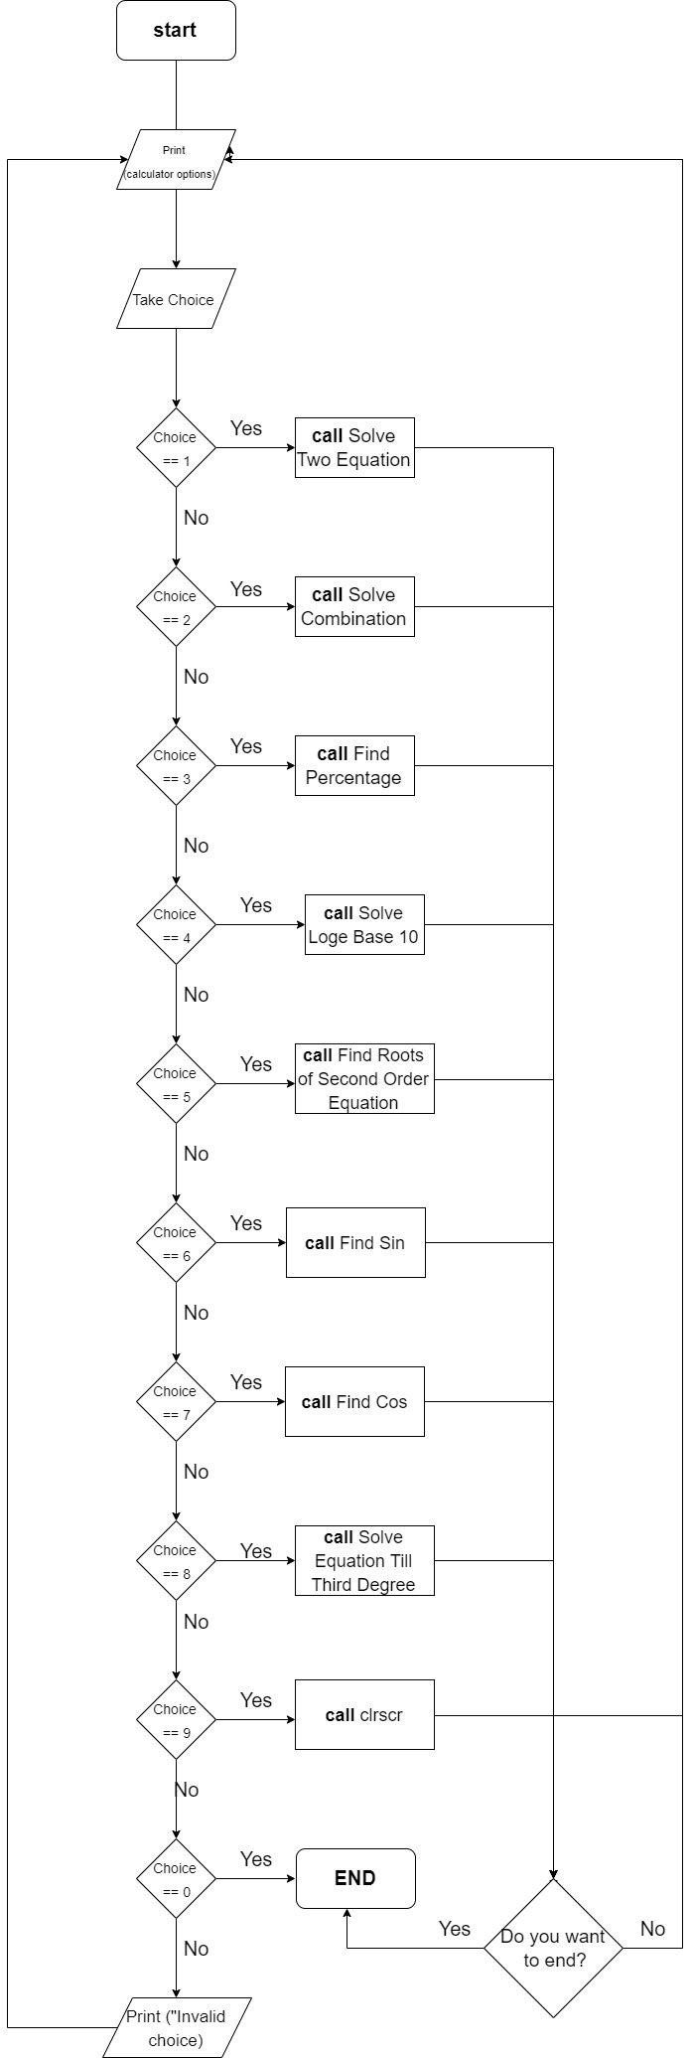
Flow Chart
Main Part

Solve Two Equation

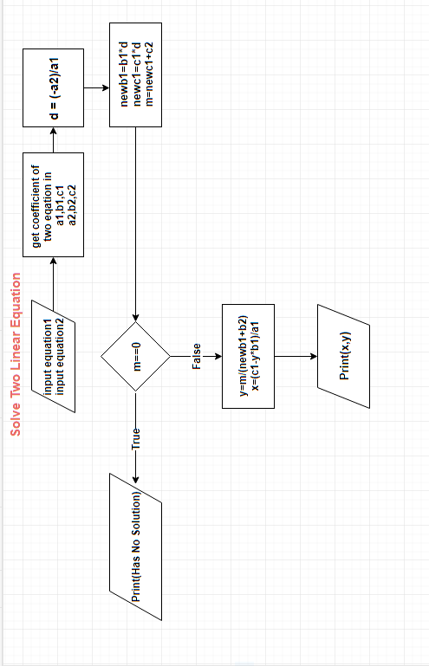

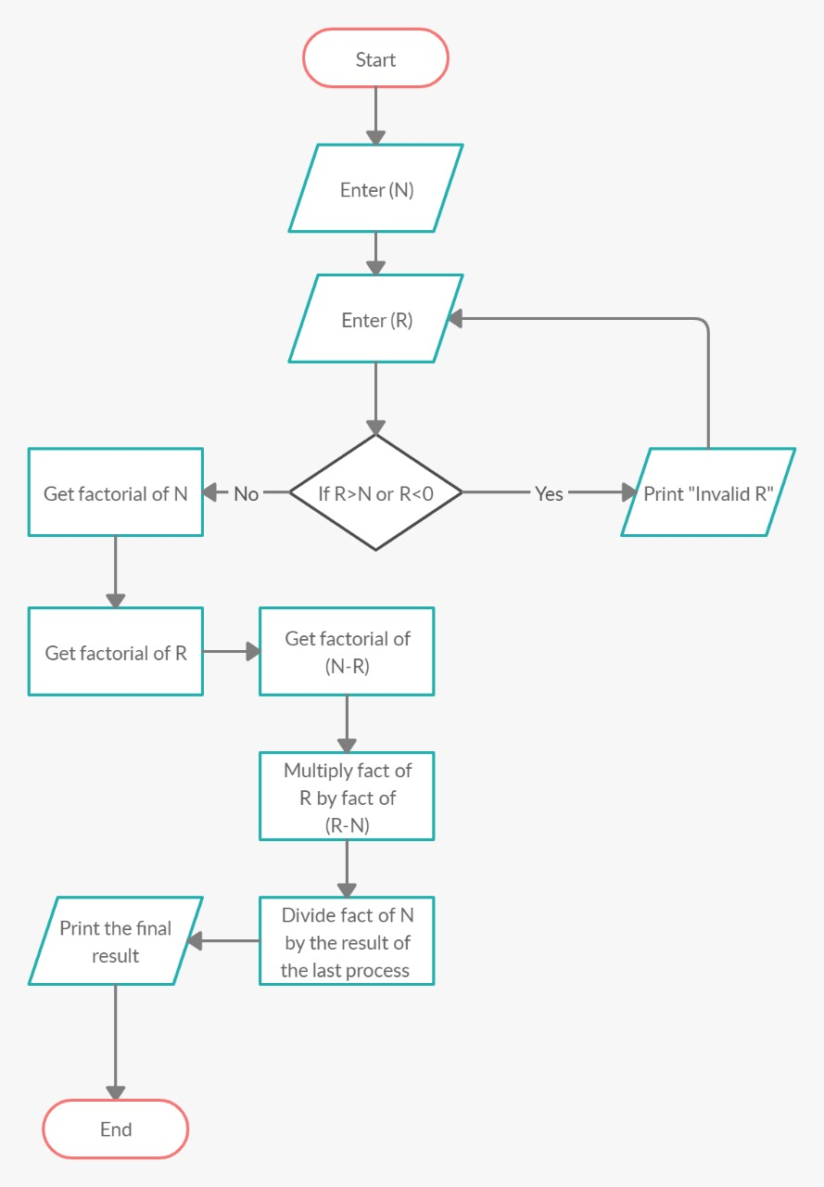
Solve Combination

Find Percentage

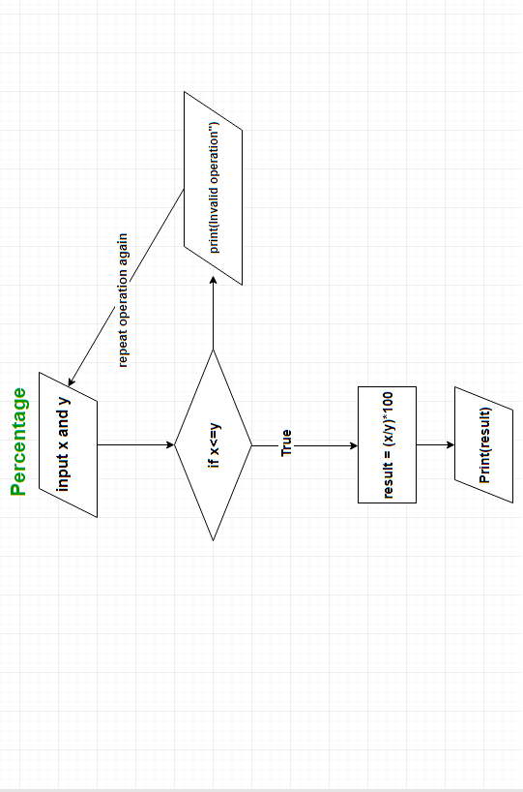

Solve Log Base 10

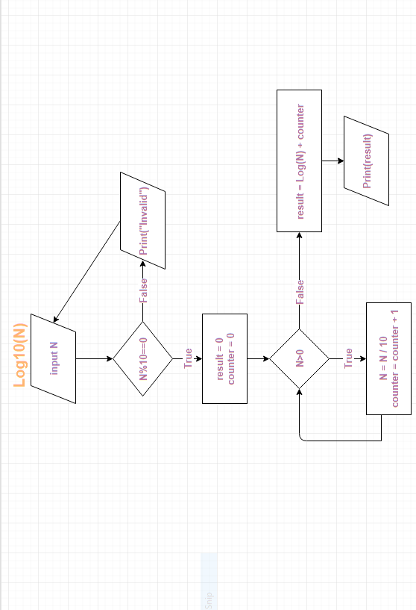

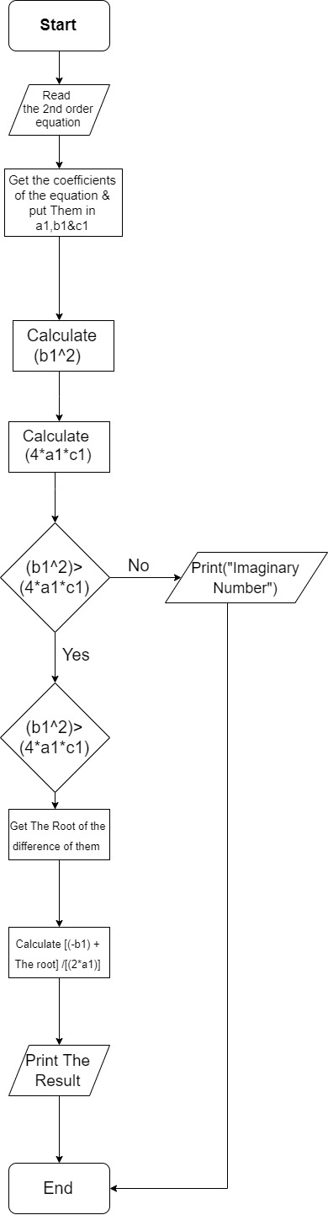
Find Roots of Second Order Equation

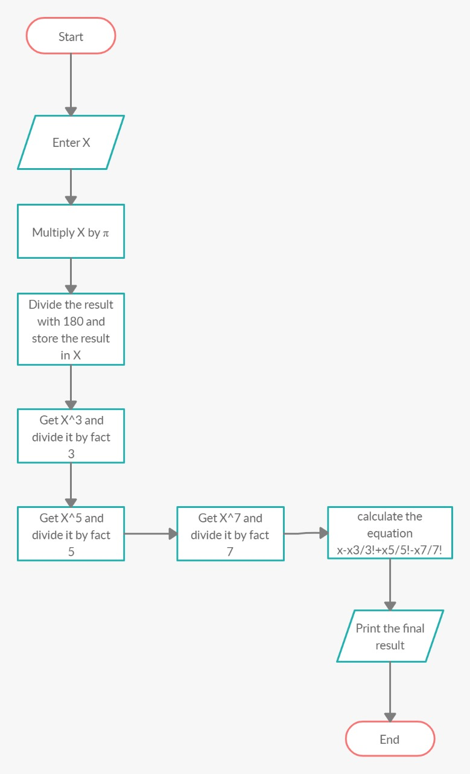
Find Sin

Find Cos

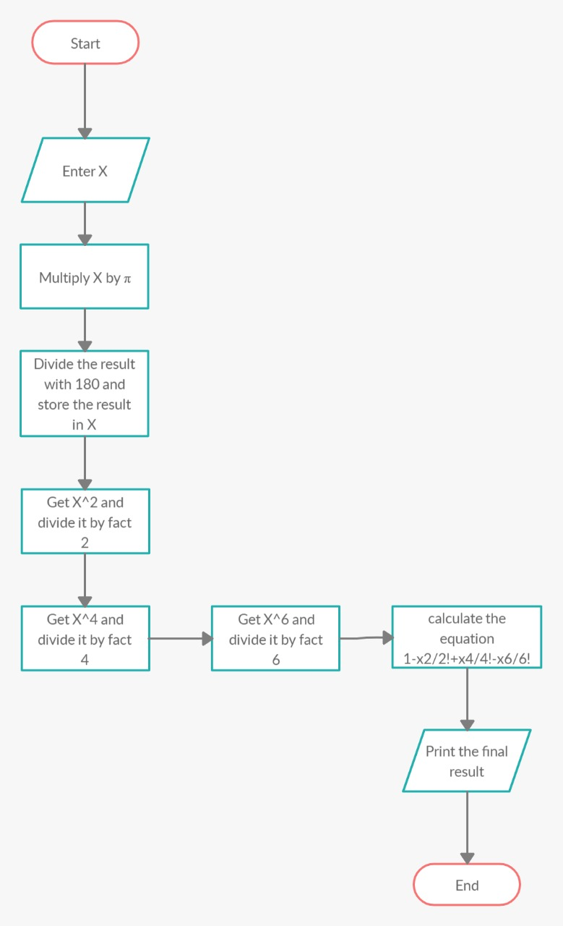

Find F(X) Until Third Degree

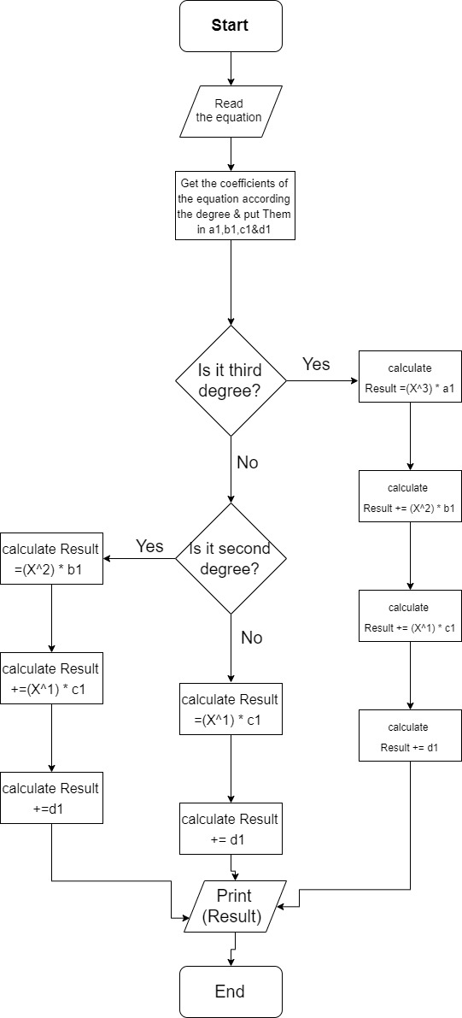

Thanks for Your Time!
Any Questions?

